Launching a Web Server on AWS EC2 Using Apache

1. Introduction
This project demonstrates how to deploy a simple web application on Amazon Web Services (AWS) using an EC2 instance and the Apache2 web server. The project focuses on launching a virtual server, configuring secure access, installing a web server, and hosting a web application accessible through a public IP address.

2. Project Objective
The objective of this project is to:
- Launch and manage an EC2 instance
- Configure firewall rules using Security Groups
- Connect to the server using SSH
- Install and manage Apache2 web server
- Deploy and access a web application via browser

3. Step-by-Step Implementation
Task 1: Create an EC2 Instance
Steps Performed:
- Logged in to the AWS Management Console.
- Navigated to EC2 → Launch Instance.
- Selected Ubuntu Server 20.04 / 22.04 LTS as AMI.
- Chose t3.micro instance type.
- Created or selected an existing key pair.
- Launched the EC2 instance.
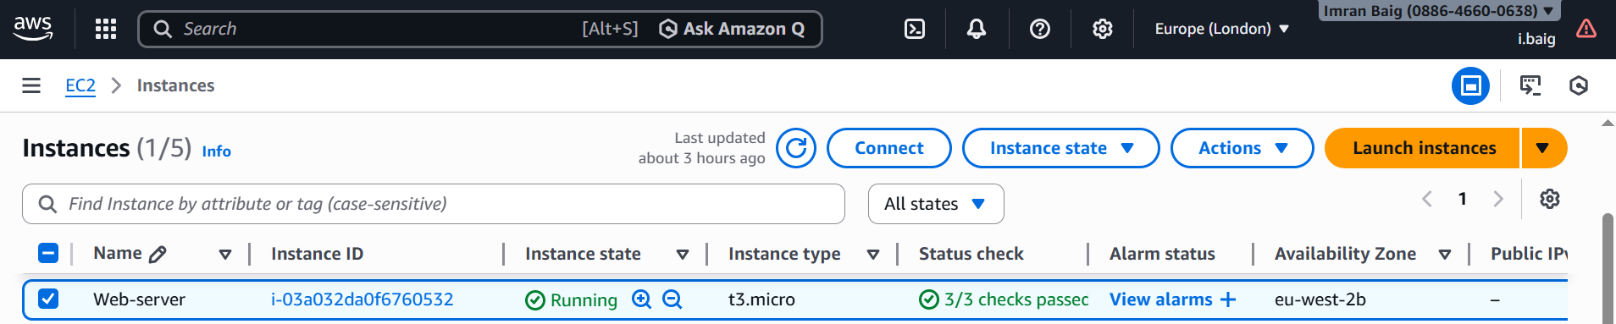

Task 2: Configure Security Groups
Steps Performed:
- Opened the security group attached to the EC2 instance.
- Edited inbound rules.
- Allowed required traffic.
Inbound Rules:
Protocol | Port | Source
SSH | 22 | 0.0.0.0/0
HTTP | 80 | 0.0.0.0/0
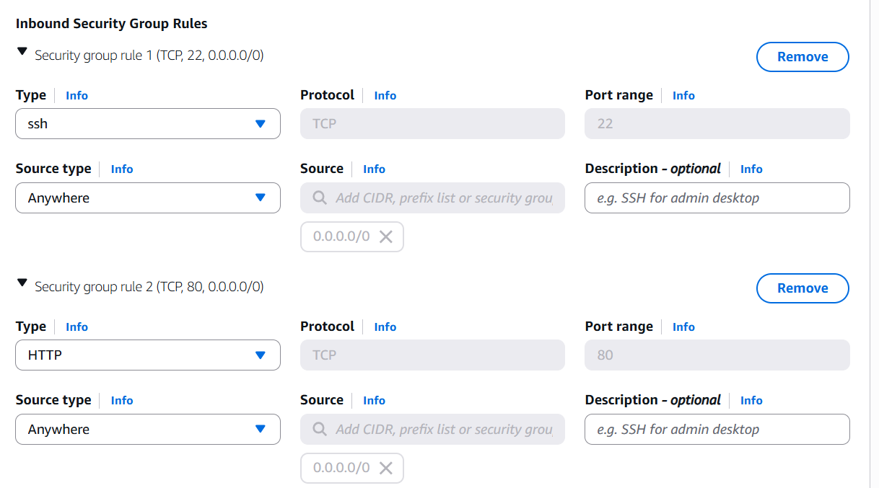

Task 3: Connect to EC2 Using SSH
Steps Performed:
- Copied the EC2 Public IPv4 address.
- Opened terminal.
- Connected using:
ssh -i your-key.pem ubuntu@<public-ip>
- Verified successful login.
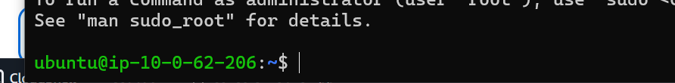

Task 4: Install and Start Apache2 Web Server
Steps Performed:
- Updated system packages:
sudo apt update
- Installed Apache2:
sudo apt install apache2 -y
- Started Apache service:
sudo systemctl start apache2
- Enabled Apache on boot:
sudo systemctl enable apache2
- Checked Apache status:
sudo systemctl status apache2
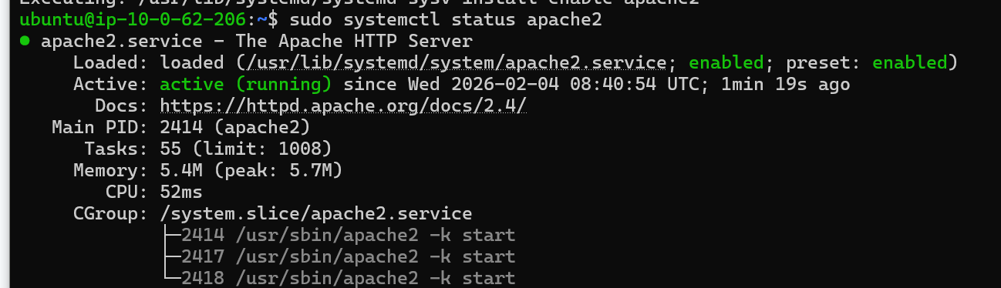

Task 5: Test HTTP Access
Steps Performed:
- Opened a web browser.
- Entered EC2 Public IP address.
- Verified Apache default page.
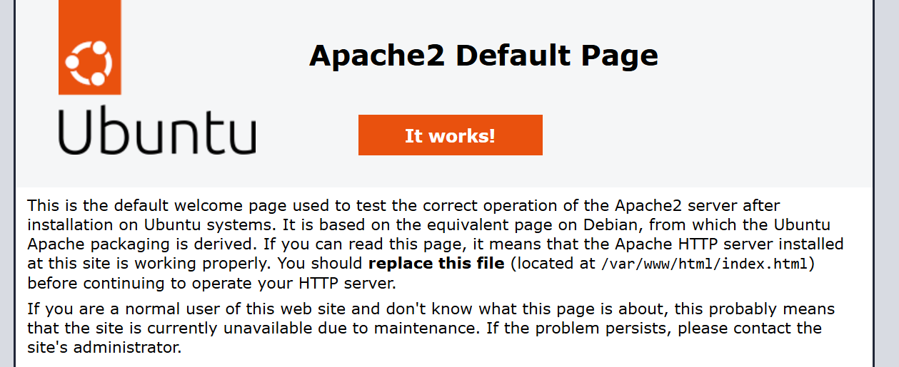

Task 6: Deploy a Sample Web Application
Steps Performed:
- Navigated to web root directory:
cd /var/www/html
- Edited index file:
sudo vi index.html
- Added custom HTML content.
- Saved and exited the file.
- Refreshed the browser.
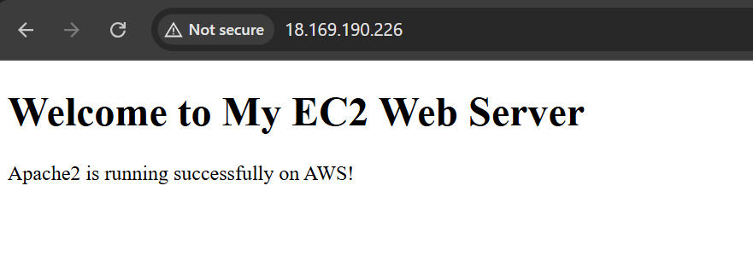

5. Challenges Faced
- SSH access failed initially due to incorrect key permissions.
- Web page not accessible until HTTP port was allowed in security group.
- Required understanding of Linux file permissions and services.

6. Key Learnings
- EC2 instance creation and management
- Security Group configuration
- SSH-based Linux server access
- Apache2 installation and management
- Web application deployment on AWS

Conclusion:
This project successfully demonstrated the deployment of a web application on AWS using EC2 and Apache2. It provided hands-on experience with cloud infrastructure, Linux server administration, and basic web hosting concepts.

